

APTECH LEARNING PAKISTAN

Aptech Metro Star Gate Center

Karachi





# ROCK-PARADISE

# GROUP-MEMBERS

|  |  |  |
| --- | --- | --- |
| **Faculty** | **SIR Mustajab Mustafa** | |
| **Batch** | **PR2-202306F** | |
| **Serial NO.** | **Enrollment NO** | **Student Name** |
| **1** | Student1487192 | MUHAMMAD FAIZ BAIG |
| **2** | Student147599 | MR.ZUBAIR HASSAN |
| **3** | Student1480137 | MR.WAJIH HUSSAIN |

Catalog

ROCK-PARADISE 1

GROUP-MEMBERS 1

CERTIFICATE OF COMPLETION 3

Acckknowledgement 4

Introduction 5

USER’S GUIDE 7

**CERTIFICATE OF COMPLETION**

This is to certify that **MUHAMMAD FAIZ BAIG , MR.ZUBAIR HASSAN, MR.WAJIH HUSSAIN,**have successfully completed their **HDSE**\*

Semester 1 E-Project.

Submitted to: **APTECH COMPUTER EDUCATION**

**ON**

**JANAUARY, 18 ,2024**

**ACKNOWLEDGEMENT**



**First of all, we would like to thank Almighty Allah for giving us strength and**

**ability to complete this project.**

**And then, we would like to express my special thanks of gratitude to our teacher SIR Mustajab Mustafa who guided us on the**

**Project *ROCK-PARADISE* which also helped us in doing a lot of new learning and we come to know about so many new things we are really thankful to him.**

**We are highly thankful to SIR Mustajab Mustafa for his guidance and constant supervision as well as for his support in completing the project.**

**Lastly, we would also like to thank our parents and friends who helped us a lot in finalizing this project within the limited time frame. We also express**

**our sincere gratitude to E-Project team from Aptech Head Office, for their valuable guidance and support for the completion of this project. We earnestly hope this project will provide all the necessary information**

**required by the user to full fill his/her inspiration. However, suggestion and Feedback for improvements will be thankfully welcomed &acknowledge.**



**The thirst for learning, upgrading technical skills and applying the concepts in real life environment at a fast pace is what the industry demands from IT professionals today. However busy work schedules, far-flung locations, unavailability of convenient time-slots pose as major barriers when it comes to applying the concepts into realism. And hence the need to look out for alternative means of implementation in the form of laddered approach. The above truly pose as constraints especially for our students too! With their busy schedules, it is indeed difficult for our students to keep up with the genuine and constant need for integrated application which can be seen live especially so in the field of IT education where technology can change on the spur of a moment. Well, technology does come to our rescue at such times!! Keeping the above in mind and in tune with our constant Endeavor to use Technology in our training model, we at Aptech have thought of revolutionizing the way our students learn and implement the concepts using tools themselves by providing a live and synchronous e-Project learning environment**



**Rock Paradise is the premier online retailer for all things crystals and gemstones. Our extensive collection includes unique stone varieties from all over the world, and we’re always on the hunt for the highest-quality products for our customers! Whether you’re looking to buy crystals for your collection or to enhance your spiritual practice with healing stones, we have something for everyone to enjoy. Explore our online crystal shop and enjoy the best the gemstone world has to offer! All our crystals at Pure Lightness are handpicked by the wonderful people we work with,& ethically sourced around the globe. We love our planet and because of this we make it a point to support companies and individuals who believe in working with the Earth and the communities in which they all live.At Rock Paradise, we’re dedicated to bringing you exciting new tumbled gemstones,crystals, clusters, rough and raw stones, towers, spheres, and more!Welcome to Rock Paradise, your source for Natural stone products. You are supposed to create a Single-Page-Application and responsive Website for them with the below mentioned requirement specifications. The website is to be developed for the Windows Platform using HTML5, JSON,Angular JS, JavaScript and Geo location. The site should work well in all leading browsers including Chrome, IE, Firefox etc.**



The portal will be designed as a Single-Page-Application and responsive Website with a set of pages and menus that represent choice of activities to be performed. The pages, menus, and other visual elements must be designed in a visually appealing manner with attractive fonts, colors, and animations.

All of these should also be laid out in a responsive manner.

The Web site is to be created based on the following requirements

1. The Top of the Page should be presented with a suitable logo and images of diamonds and other crystals.
2. Categories such as Diamond, Quartz, Ruby, Sapphire, Emerald etc with listing of various jewelry items consisting these crystals.
3. Top Selling Items should be listed in a separate category.
4. Filters based on brand, colour, size etc. should be provided.
5. Brands like “Swarovski”, “Tiffany”, “Pandora” should be provided in filter.
6. Gallery should be added for viewing different images.
7. User Rating must be allowed to enter and viewer should have option to filter on Ratings.
8. Site map, Gallery, about us, FQA, Contact us link must be added.
9. About Us and Contact Us: This menu option should display Email id, address, and contact number.

.

1. Section for various offers in the store should be provided with listing of offers with details.
2. Color combination must be uniform throughout the project.
3. Navigation must be smooth

**Over and above this, the portal should implement the following functionalities:**

1. **Display a continuous scrolling ticker at the bottom of the page with current date,**
2. **time, and location (hint: Use geolocation features of HTML5).**
3. **Display a visitor count at the top right corner of the page beside a logo image.**
4. **The menu options should change color on hover and also after clicking.**
5. **Fade in and fade out options can be used for the menus.**

# USER’S GUIDE

## PROJECT INTERFACE

Prototype (Screen Shot of the Project Interface)

1. **Home :**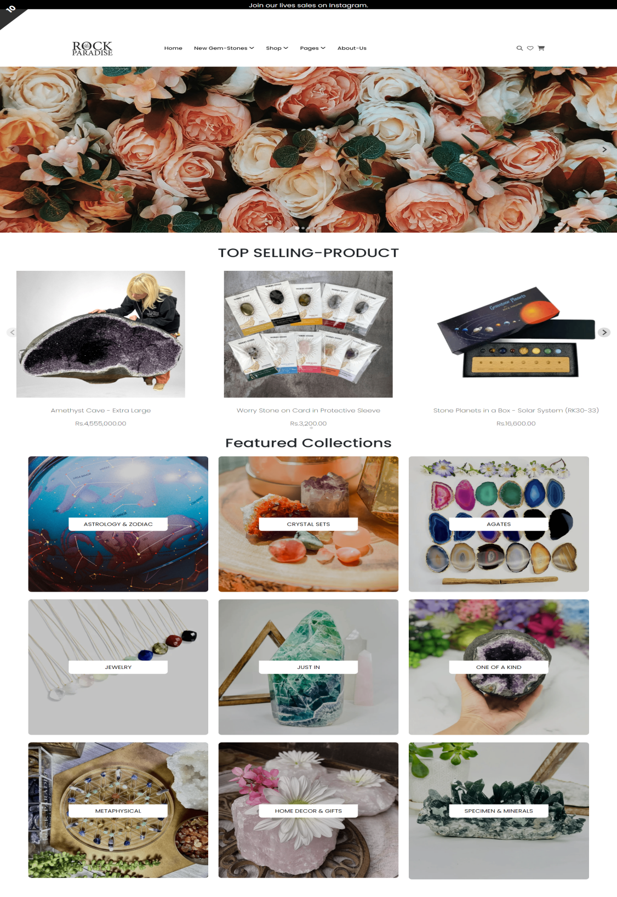

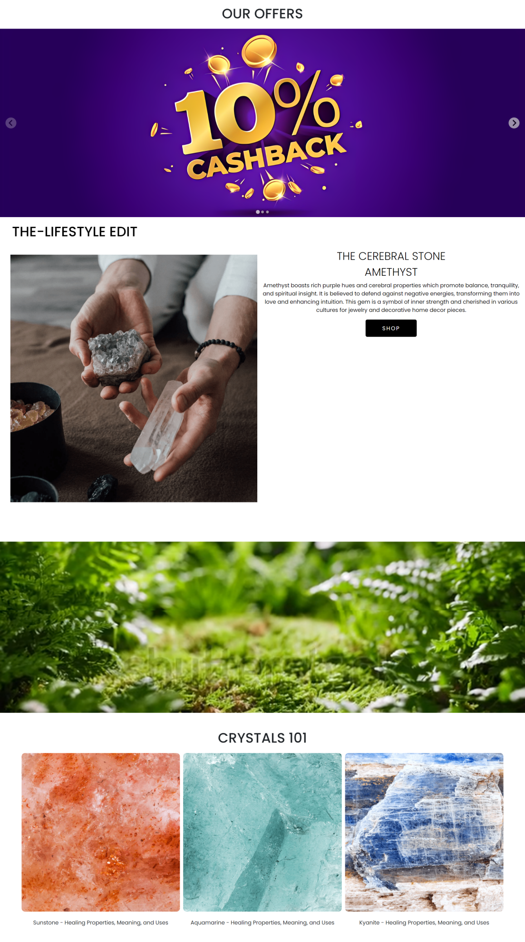

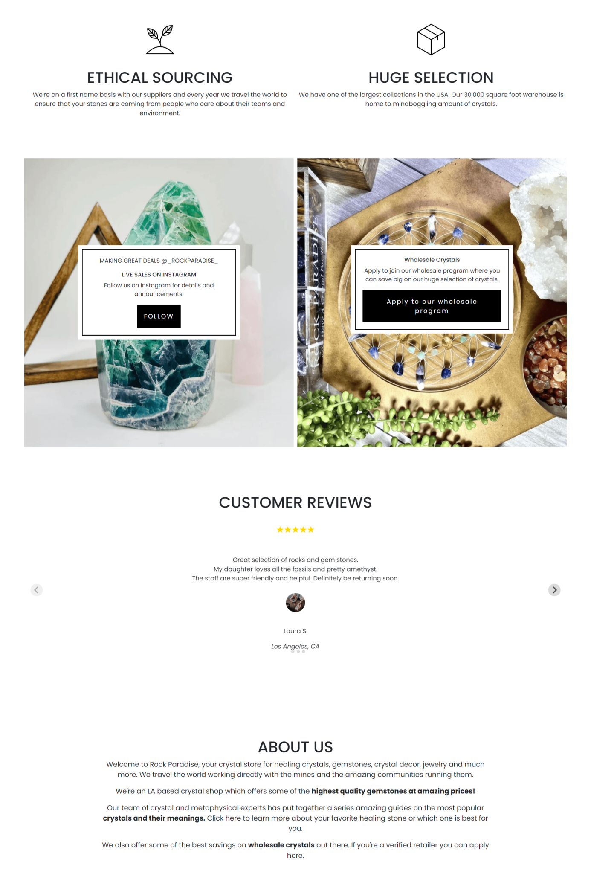

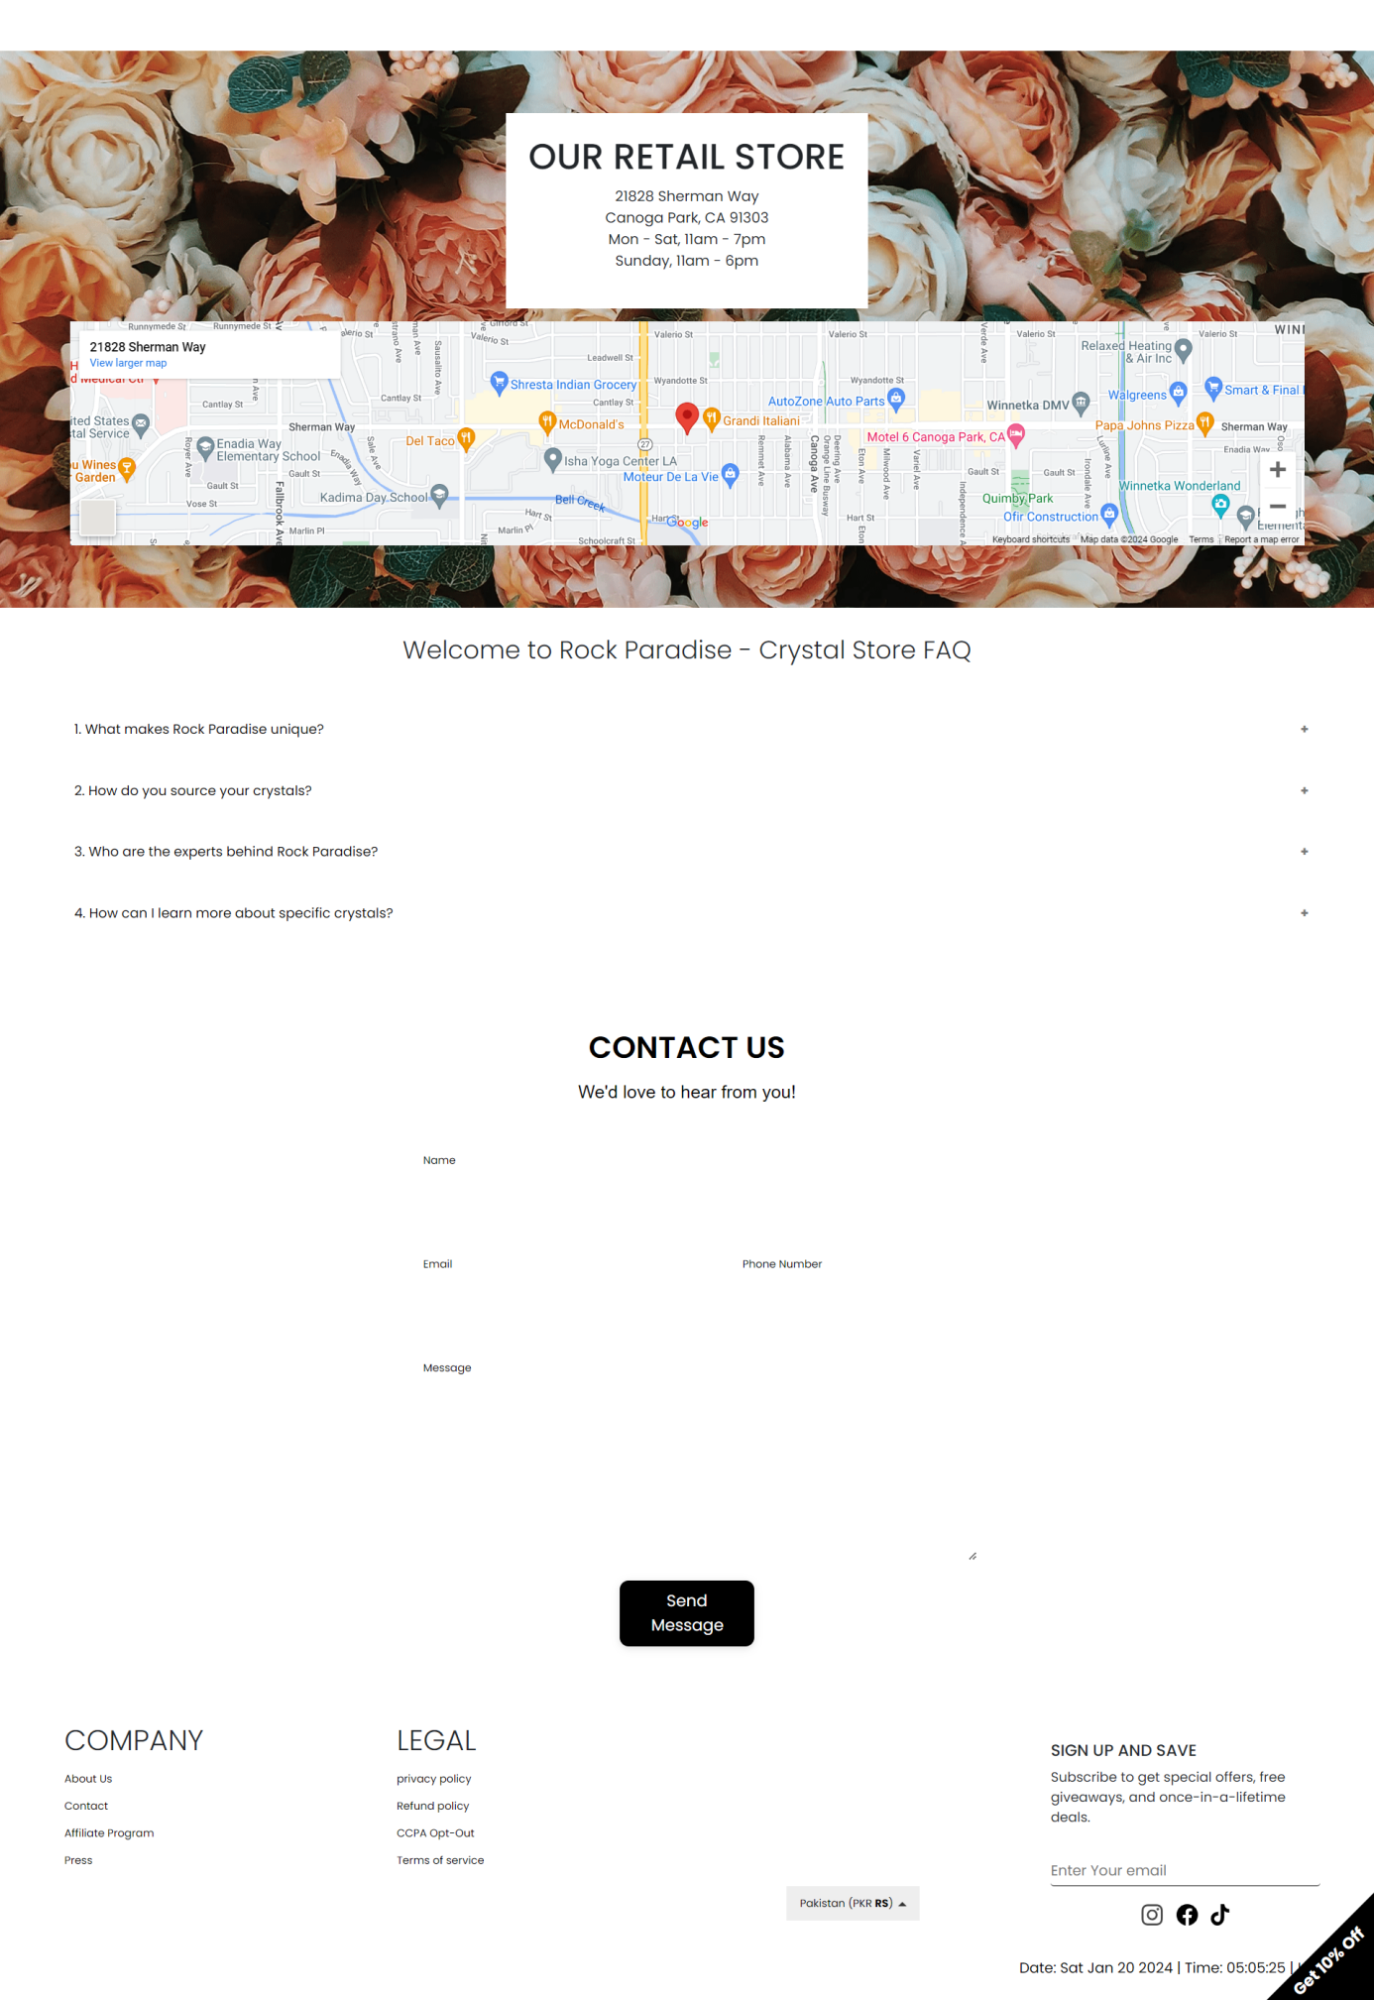

1. **Header:**



1. **Top Selling Product:**

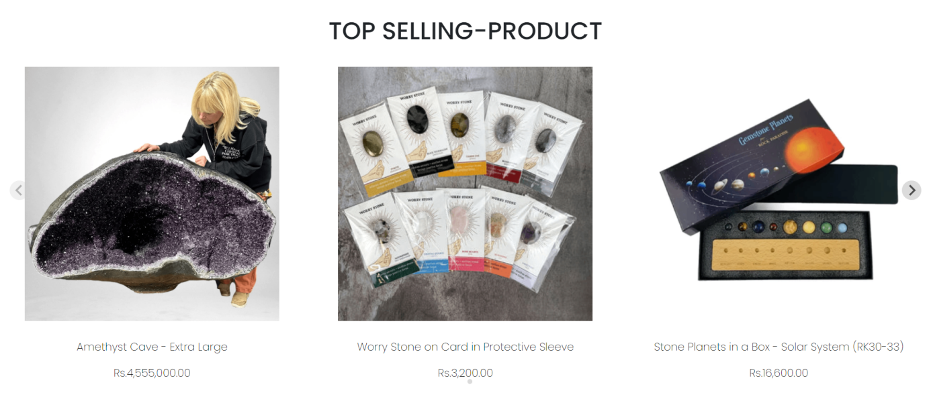

1. **Our Offers:**



1. **About us:**

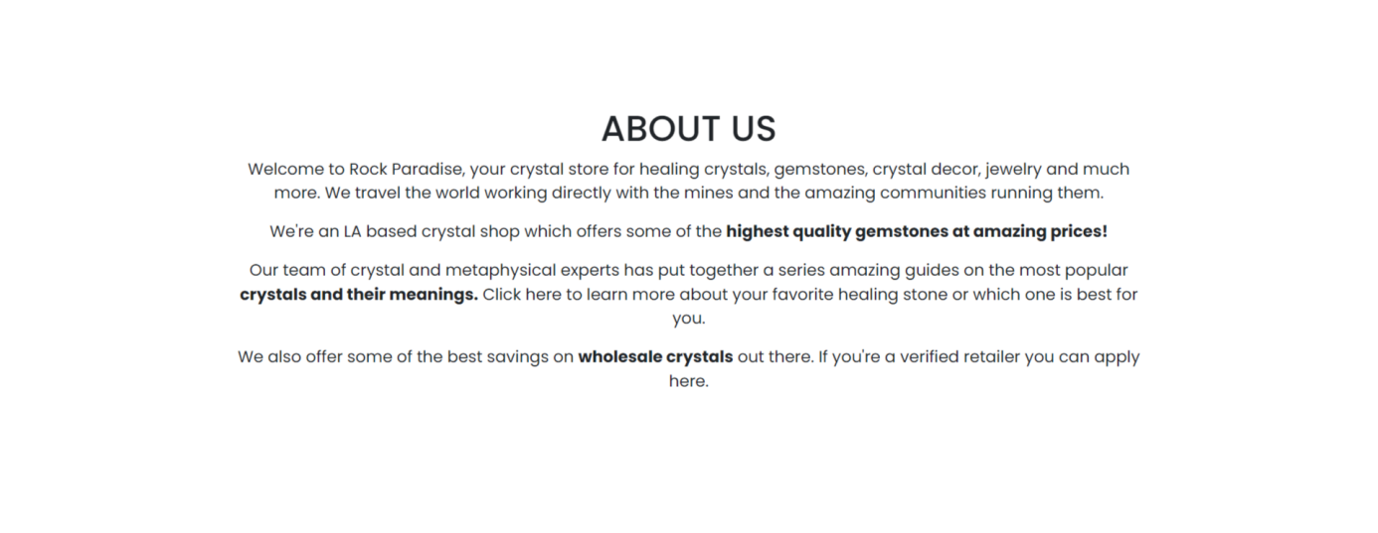

1. **Site Map:**

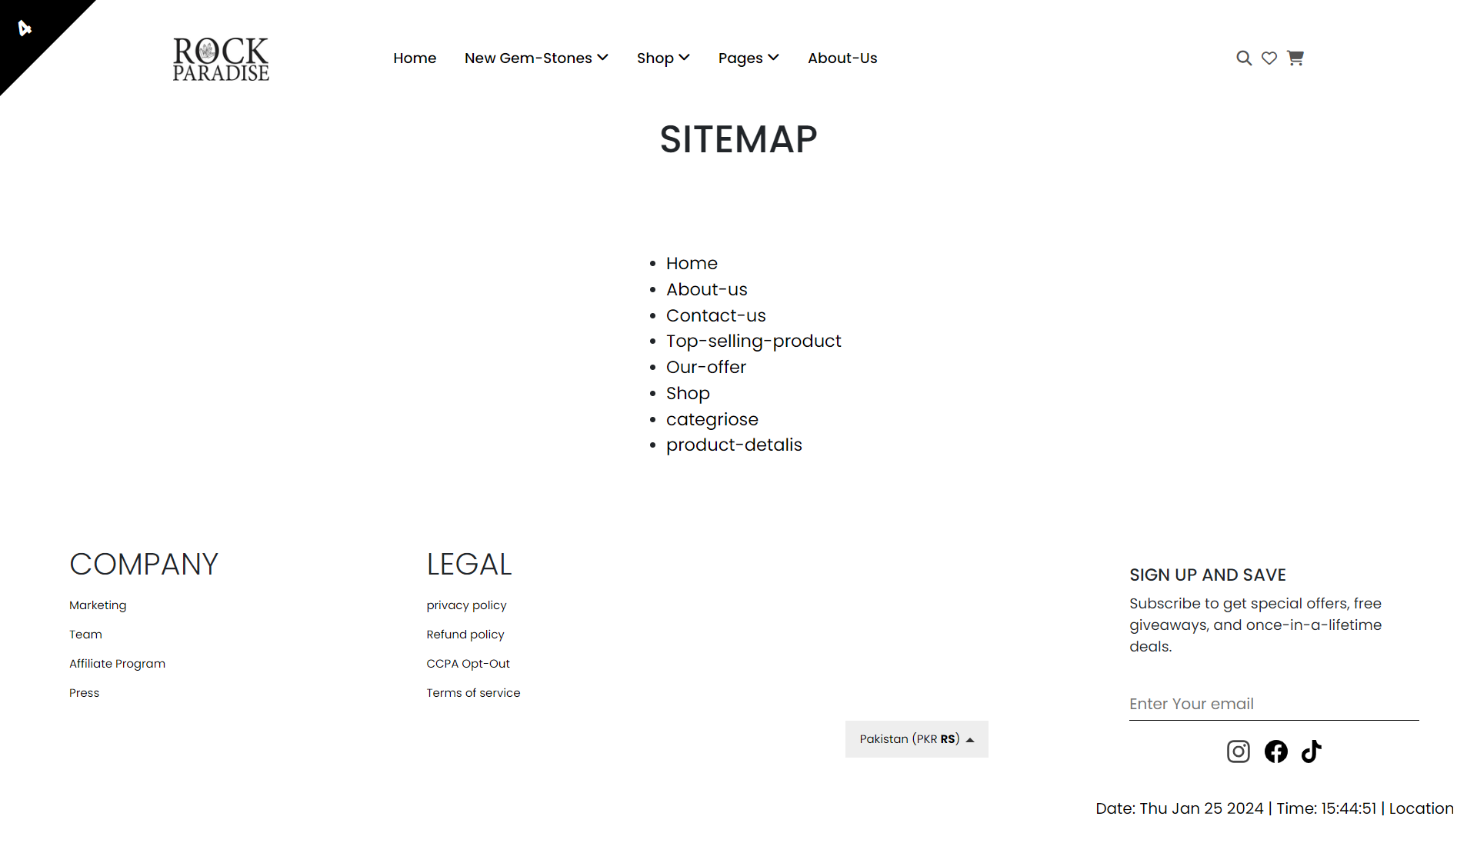

1. **Faq:**

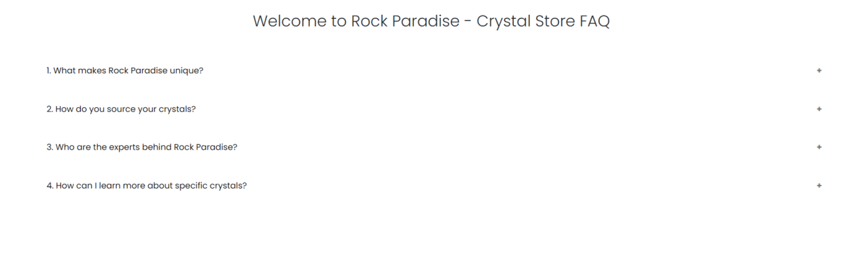

1. **Footer:**



**Shop:**

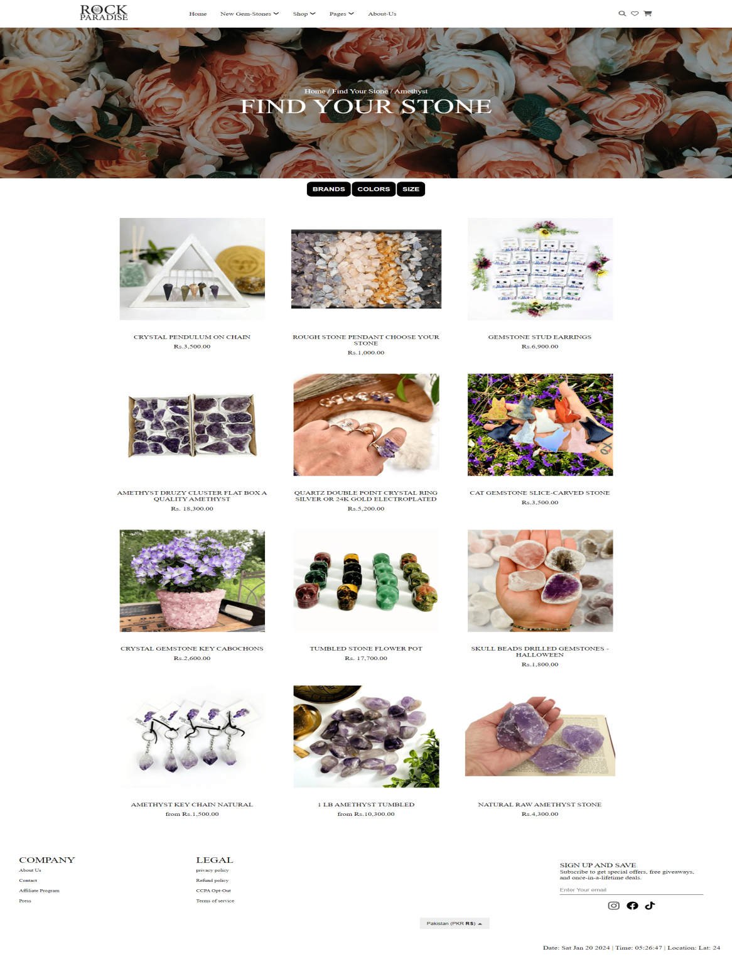

**Categories:**

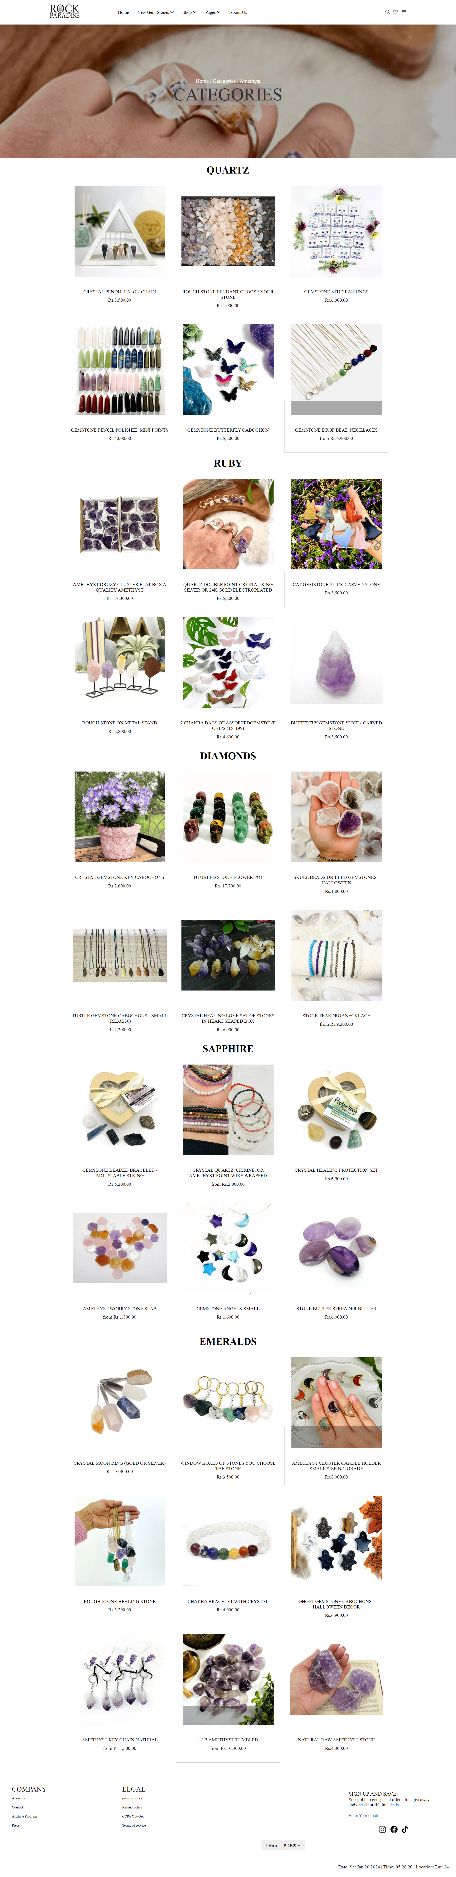

**Product page:**

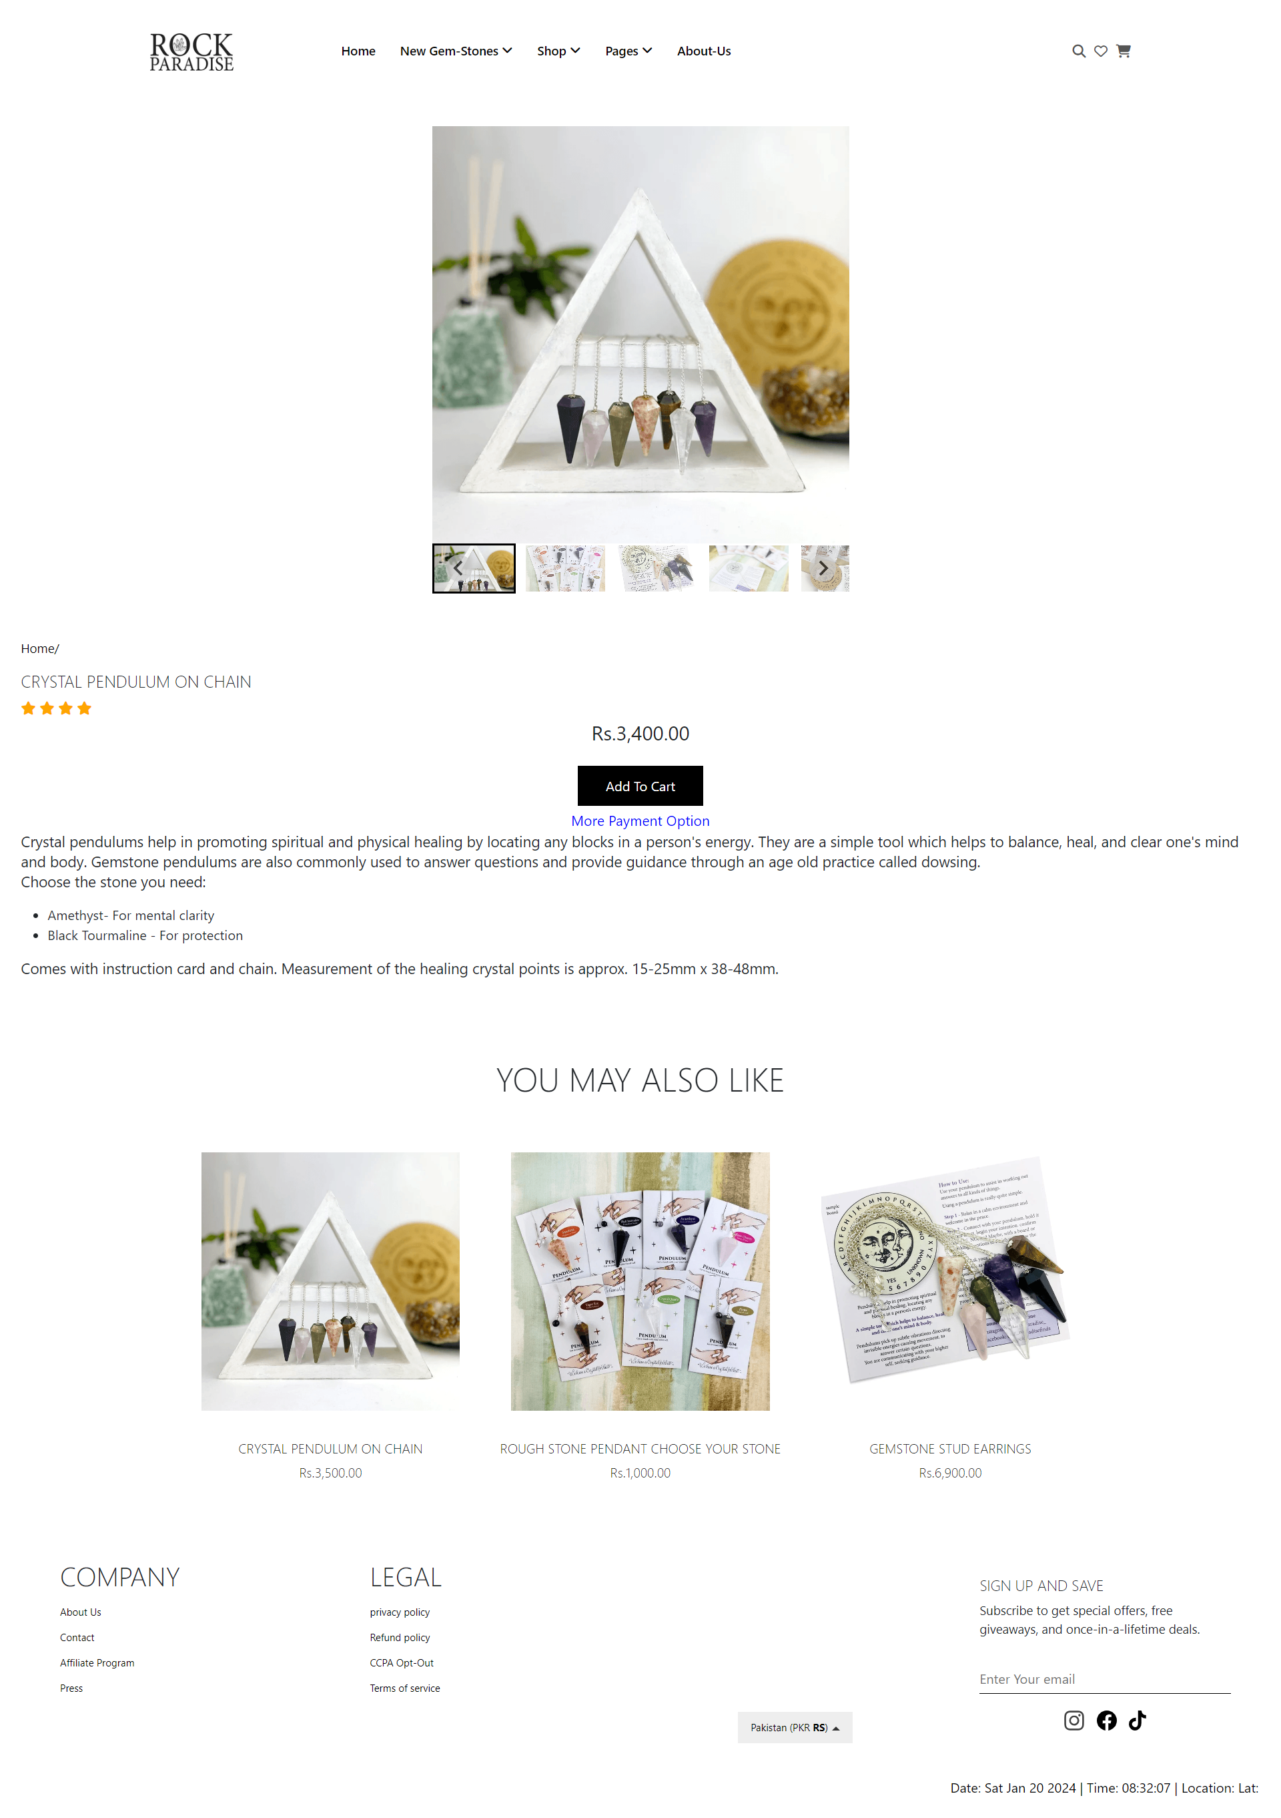

# REQURIMENTS

1. The Top of the Page should be presented with a suitable logo and images of diamonds and other crystals.



2)Categories such as Diamond, Quartz, Ruby, Sapphire, Emerald etc with listing of various jewelry items consisting these crystals.



3)Top Selling Items should be listed in a separate category.



1. Filters based on brand, colour, size etc. should be provided.

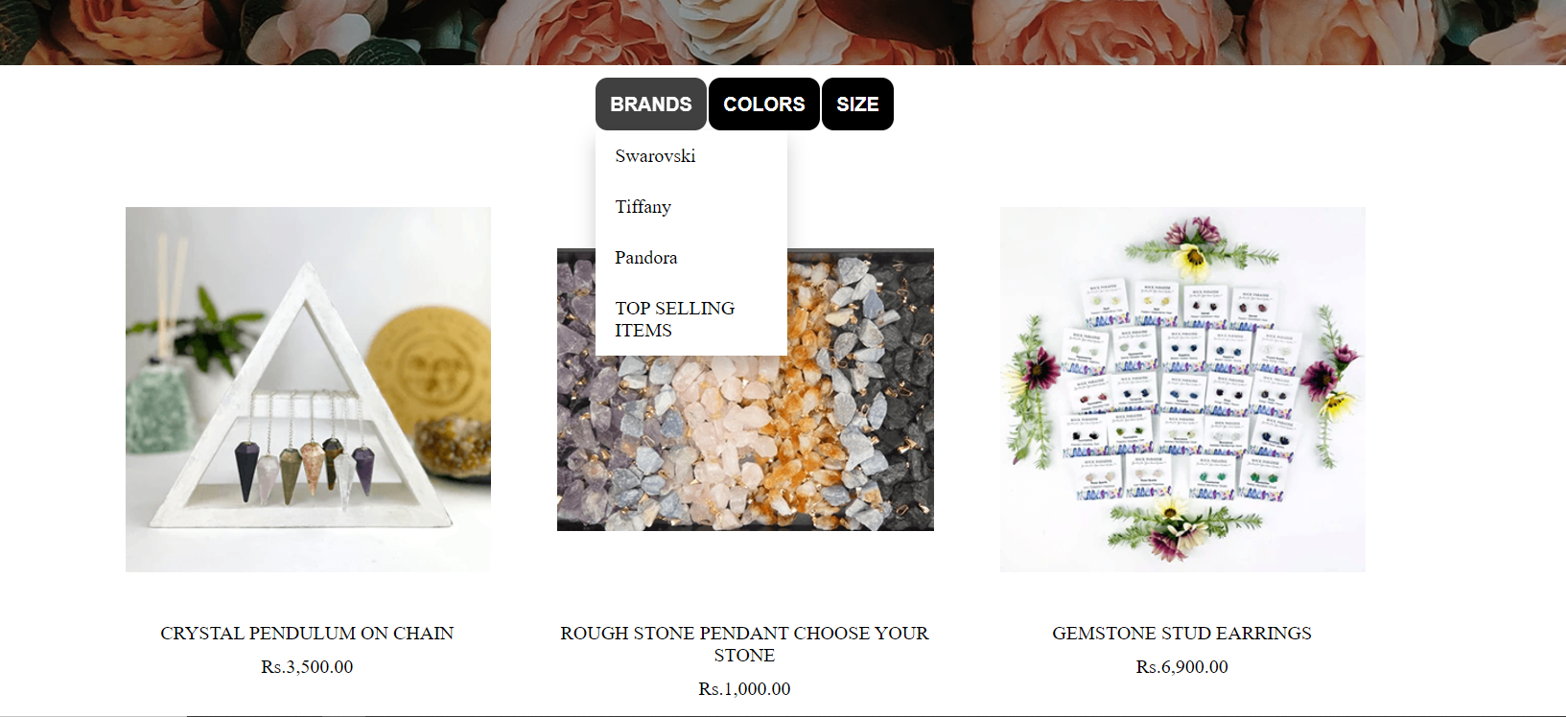

1. Brands like “Swarovski”, “Tiffany”, “Pandora” should be provided in filter.



1. Gallery should be added for viewing different images.



1. User Rating must be allowed to enter and viewer should have option to filter on Ratings.



1. Site map, Gallery, about us, FQA, Contact us link must be added.



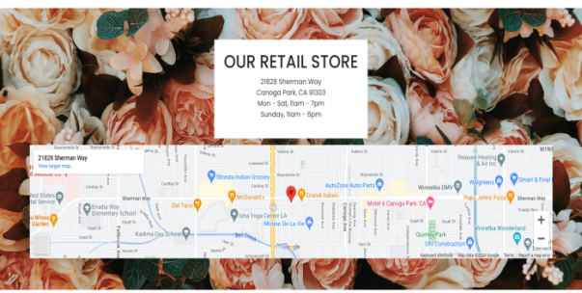

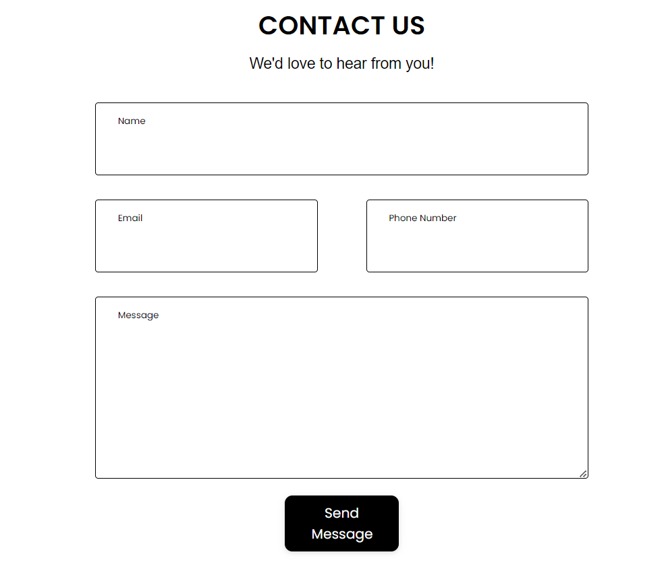

1. About Us and Contact Us: This menu option should display Email id, address, and contact number.

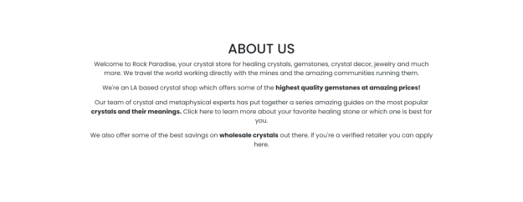

10)Section for various offers in the store should be provided with listing of offers with details.****

11)Display a continuous scrolling ticker at the bottom of the page with current date,

time, and location (hint: Use geolocation features of HTML5).

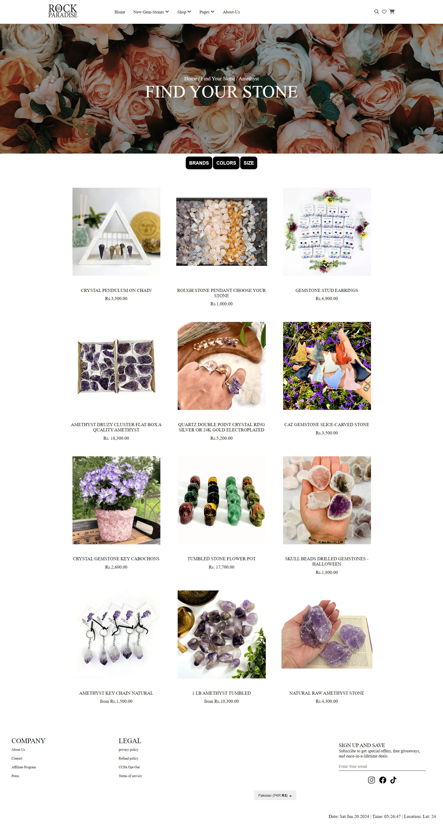

1. Display a visitor count at the top right corner of the page beside a logo image.



1. The menu options should change color on hover and also after clicking.



1. Fade in and fade out options can be used for the menus.



**Signature: _____________**